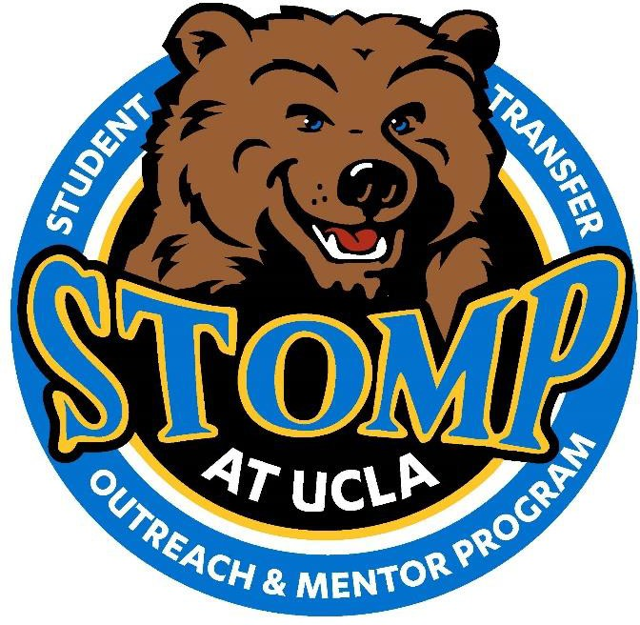

◄◄ PAID COORDINATOR POSITION AVAILABLE ►►
Student Transfer Outreach and Mentor Program (STOMP) was created by UCLA students who sought to ensure that 4-year collegiate institutions remain accessible to students enrolled at California community colleges. As a program of UCLA Undergraduate Admission, STOMP works under the supervision of the Transfer Recruitment Unit to outreach and mentor prospective transfer students, many who come from underrepresented communities.

Primary Roles
The STOMP Coordinators' primary roles are to supervise the STOMP Club (all volunteers), and lead the programmatic efforts of STOMP, including the annual STOMP Conference. Coordinators are responsible for working with the UCLA Student Organizations, Leadership & Engagement (SOLE) Advisor to submit funding applications on time. In addition, the STOMP Coordinator supports Undergraduate Admission programming, especially those aimed at outreach and recruitment for prospective transfer students. In many cases, STOMP students engage highly qualified, yet doubtful community college students.
**Please note that for the 2021-2022 academic year, this position will operate on a hybrid schedule**

Desired Qualifications
- Highly organized and ability to balance multiple responsibilities
- Strong interpersonal, verbal, and written communication skills
- Passion for higher education and strong sense of care for transfer student success
- Flexibility to visit community colleges with Undergraduate Admission Officers (virtually and/or in person)
- Work-study is highly preferred

Required Qualifications
- Must be able to work 8-10 hours a week
- Must be able to work virtually and/or in person
- Must be able to lead STOMP meetings
- Must be a current full time UCLA student in good academic standing; Maintain a 3.25 GPA or higher
- Must be able to provide proof of eligibility to work in the U.S. upon hire
- Pay Rate: $16.50/ hour
Complete applications must be submitted via email by Friday, October 22nd at 5pm.
Email applications to Erika Perez at eperez@admission.ucla.edu and Lila Mendoza lmendoza@admission.ucla.edu.

Our office is located at 2385 Wooden Center, and is sponsored by UCLA Undergraduate Admission. For any inquiries, please contact Erika Perez or Lila Mendoza via email.

STOMP Leadership Application
STUDENT TRANSFER OUTREACH AND MENTOR PROGRAM

Personal Information

Last Name: Preferred Name:
First Name:

Current Address:

Phone Number: University ID:
Email: Year in School:

Major(s):
Expected Graduation Term: Transfer Student (circle one): YES / NO
(Being a transfer student is not requirement)
Minor(s): Quarters Completed at UCLA:

If so, where did you transfer from:

Position Information

Position(s) Seeking: STOMP COORDINATOR

Please list any current commitments that you have including, but not limited to: other employment, student organization involvement, leadership roles, research, etc. Please indicate whether at UCLA, your previous school, or within your community.

Please list any student organizations in which you have been involved, as well as any leadership roles you held/hold. Please indicate whether at UCLA, your previous school, or within your community.

Short Answer Responses
Please answer the following questions on a separate sheet of paper. Use up to 250 words for each response.

- Describe your experience in higher education. Provide a personal experience that you feel useful to share with a prospective transfer student.
- Why are you interested in this position and STOMP? How do you plan to contribute to the STOMP space?
- What do you feel is the greatest attribute of a transfer student? Elaborate on your personal experiences either as a transfer student, or engaging transfer students.
- What experience do you have in program planning? Include aspects of funding if applicable.
- Have you participated in STOMP? If so, please share your previous STOMP experiences.

Current Class Schedule

Please submit a copy of your current class schedule with your application.

Cover Letter and Resume

Please submit a copy of your cover letter and resume.

Application Checklist

Complete and return the following items to Erika Perez and Lila Mendoza via e-mail at
eperez@admission.ucla.edu AND lmendoza@admission.ucla.edu by Friday October 22nd at 5:00 PM.

  - Completed STOMP Leadership Application
  - Short responses on a separate sheet of paper (250 words maximum for each response)
  - Current class schedule (Fall Quarter 2021)
  - Cover letter and resume

Applicant Name:

Applicant Signature:

Date:

